 京制01050054号

**Instruction Manual**

**DMF-1-Series Coriolis Mass Flow Meter**

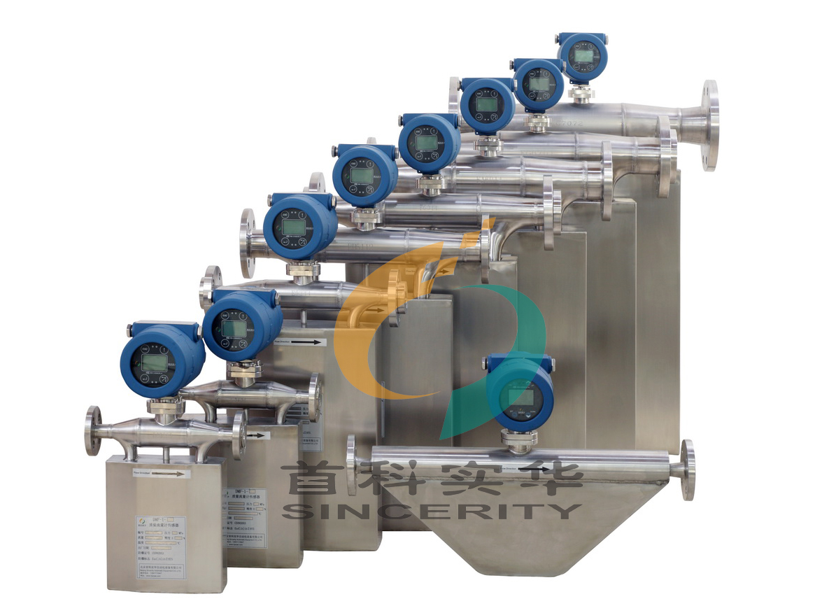

**Beijing Sincerity Automatic Equipment Co., LTD**

**Tel: +86-010-62469399**

**Phone: +86-18600270515**

Content

Introduction3

Measuring Principle4

Technical Parameters6

Module Selection7

Structure10

Operating Conditions: Installation20

Sensor Installation20

Transmitter & Sensor Connection25

Energizing & Inspection26

Maintenance27

Settings28

Function Settings28

Instruction Panel28

Operation Interface29

Explosive Prevention34

Principles of Anti-explosion systems34

Documentation: Standard RS 485 Communication35

**Introduction**

DMF-1-Series Coriolis Mass Flow Meters’ measuring principle is based on the controlled generation of Coriolis forces. The measurement would not be affected by the **pressure, temperature, viscosity, density,** etc. And the compensation calculation is not required. The structure contains two parts: Sensor & Transmitter. The Coriolis Mass Flow Meters are designed and manufactured based on the national standard of safe explosion proof. The Explosion- proof standard is EX d ib II C T5 Gb.

The mass flow meter does not measure the volume per unit time (e.g., cubic meters per second) passing through the device; it measures the mass per unit time (e.g., kilograms per second) flowing through the device. The accuracy of the Coriolis Mass Flow Meters is ±0.1%~ ±0.2%. The application range is large. (It could be used to measure all sorts of all sorts non-newtonian fluid, slurry, suspensions, high viscosity fluid, etc.) The requirements for the installation are low. (The straight pipe requirements in front of and behind the Coriolis Mass Flow Meters are low.) They are more reliable, stable, and the maintenance level is low.

Beijing Sincerity Automatic Equipment Co., LTD has the ultimate power of interpretation of the description of all content, and shall have the right to modify the content of the instruction manual.

|  |
| --- |
| **Attention** |
| **Improperly installation and operations in dangerous occasions will come with serious consequences** |
| **Please refer to the anti-explosion part for the technical parameters about the dangerous occasions.** |

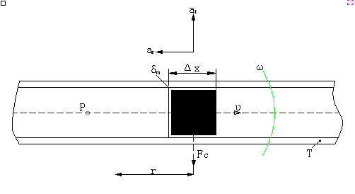**Measuring Principle**

The measuring principle is based on the controlled generation of Coriolis Forces. Figure in the quality of the δm at a constant speed v of particles revolve around a fixed point P with angular velocity omega ω movement of the pipe, the particle will receive two acceleration components:

1. The normal acceleration αr (centripetal acceleration), its value is equal to the ω2r, direction toward the point P;

2. The tangential acceleration of αt (coriolis acceleration), its value is equal to 2ωv, omega direction perpendicular to αr.

According to Newton's second law of motion (force = mass* acceleration). If it is required to produce coriolis acceleration αr., there must be in the direction of the αt exert a corresponding force. It is equal to 2ωvδm. And this force comes from in the pipeline. Reverse the force acting on the pipeline, Fc =2ωvδm (hereinafter referred to as the coriolis force). Diagram, fluid delta m = rho A Δ x, so the coriolis force can be represented as:

ΔFc=2ωvδm=2ωvρAΔx=2ωδqmΔx

Type: A is cross-sectional area for the pipe

δqm=δdm/dt=vρA

For a specific rotating pipe, its frequency characteristic is certain, Δ Fc only depends on the δqm, therefore, directly or indirectly measured flow in the rotating pipe of the coriolis force imposed by the fluid can be measured mass flow rate, this is the basic principle of coriolis mass flow meter.

**Density measurement:**

The measuring tubes are continuously excited at their resonance frequency. A change in the mass and thus the density of the oscillating system (comprising measuring tubes and fluid) results in a corresponding, automatic adjustment in the oscillation frequency. Resonance frequency is thus a function of fluid density. The microprocessor utilizes this relationship to obtain a density signal.

|  |
| --- |
| **Attention** |
| **Power supply voltage may result in serious consequences** |
| **Please make sure to cut the power off before the installation and maintenance** |

|  |
| --- |
| **Attention** |
| **Improperly installation may result in damage of the Coriolis Mass Flow Meters** |
| **Please refer to the installation and connection part of the instruction manual for detailed information** |

**Technical Parameters & Module Selection**

**Technical Parameters**

|  |  |
| --- | --- |
| Applications | Suitable for Liquid, Gas, Liquid- Solid, Gas- Solid, Liquid- Gas Mass Measurement or volume measurement |
| Material of the Measurement Pipeline | SS 316L/ HC Hastelloy |
| Pressure | Please refer to the chart shown above. Special orders would be placed for high pressure. |
| Medium Temperature | -50℃～+150℃; (Highest Temperature: +350℃; Lowest Temperature: -300℃ could be special ordered.) |
| Environment Temperature | Sensor：-40℃～+150℃; Transmitter：-20℃～+70℃ |
| Flow Rate Measurement Accuracy | ± 0.2% 、± 0.1% optional |
| Density Measurement Accuracy | ±0.002g/cm³、±0.001g/cm³ optional |
| Repeatability | ±0.10% Flow Rate ±[½(Zero Point Stability/Flow Rate)×100]% Flow Rate |
| Output Signal | 4～20mA   Load Resistance <500Ω（Instantaneous or Density optional）； 0～10kHz  Instantaneous Flow Rate Pulse Signal; Standard RS 485 Communication |
| Explosion- Proof Symbol | EX d ib  II C T6 Gb |

**Module Selection:**

**Micro Flow Meter**

|  |  |  |  |  |
| --- | --- | --- | --- | --- |
| **Model** | **DN** | **Measurement scope（kg/h）** | **Work Pressure （MPa）** | **Connection type (mm)** |
| **DMF-1-3S** | 3 | 0~40 | 0~32 | Weld Joints Φ6×1.5 |
| **DMF-1-S6** | 6 | 0~100 | 0~25 | Weld Joints Φ10×2 |
| **DMF-1-S8** | 8 | 0~200 | 0~20 | Weld Joints Φ10×1 |

**Medium-Small Flow Meter:**

|  |  |  |  |  |
| --- | --- | --- | --- | --- |
| **Model** | **DN** | **Measurement scope (kg/h)** | **Work Pressure (MPa)** | **Connection Type(mm)** |
| **DMF-1-U10** | 10 | 0～500 | 0～25 | Weld Joints Φ20×4 |
| **DMF-1-U15** | 15 | 0～1000 | 0～25 | Weld Joints Φ20×3 |
| **DMF-1-U20** | 20 | 0～3000 | 0～25 | Weld Joints Φ20×2 |
| **DMF-1-U25** | 25 | 0～10000 | 0～25 | Weld Joints Φ31×3 |

**Large-scale Flow Meter:**

**High pressure could be special ordered. (4~70MPa)**

|  |  |  |  |  |
| --- | --- | --- | --- | --- |
| **Model** | **DN** | **Measurement scope (t/h)** | **Work Pressure (MPa)** | **Connection Type(mm)** |
| **DMF-1-U10** | 10 | 0-0.5 | 0～4 | Flange 10 |
| **DMF-1-U15** | 15 | 0-1.0 | 0～4 | Flange 15 |
| **DMF-1-U20** | 20 | 0-3.0 | 0～4 | Flange 20 |
| **DMF-1-U25** | 25 | 0-10 | 0～1.6 | Flange 25 |
| **DMF-1-U40** | 40 | 0-20 | 0～1.6 | Flange 40 |
| **DMF-1-U50** | 50 | 0-30 | 0～1.6 | Flange 50 |
| **DMF-1-U65** | 65 | 0-50 | 0～1.6 | Flange 65 |
| **DMF-1-U80** | 80 | 0-100 | 0～1.6 | Flange 80 |
| **DMF-1-U100** | 100 | 0-150 | 0～1.6 | Flange 100 |
| **DMF-1-U125** | 125 | 0-200 | 0～1.6 | Flange 125 |
| **DMF-1-U150** | 150 | 0-300 | 0～1.6 | Flange 150 |
| **DMF-1-U200** | 200 | 0-500 | 0～1.6 | Flange 150 |

**Structure:**

**Structure of the Sensor & Hole Opening Draft**

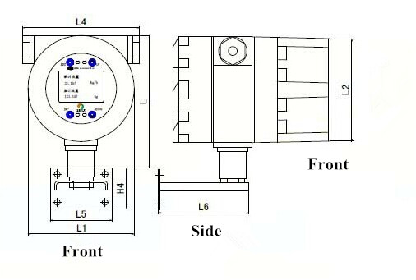

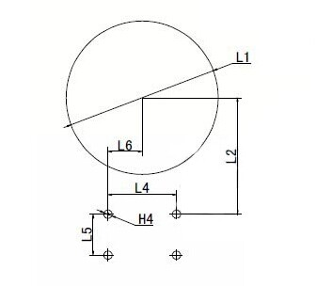

|  |  |  |  |  |  |  |  |
| --- | --- | --- | --- | --- | --- | --- | --- |
|  | **L** | **L1** | **L2** | **L4** | **L5** | **L6** | **H4** |
| **Transmitter** | 156 | 125 | 118 | 130 | 70 | 102 | 46 |
| **Hole Opening** |  | 120 | 91 | 54 | 32 | 27 | Φ6.5 |

**Dimensions of Coriolis Mass Flow Meters with tiny flow rate- DMF-1-S3、DMF-1-S6、DMF-1-1-S8**



|  |  |  |  |  |  |  |  |  |
| --- | --- | --- | --- | --- | --- | --- | --- | --- |
| **Module** | **ConnectionΦ** | **L** | **L1** | **H** | **H1** | **H2** | **W** | **Q(Diameter)** |
| **DMF-1-S3** | 6 | 205 | 185 | 220 | 160 | 115 | 52.5 | 7 |
| **DMF-1-S6** | 10 | 205 | 185 | 220 | 160 | 115 | 52.5 | 7 |
| **DMF-1-S8** | 10 | 208 | 188 | 245 | 185 | 117 | 58.5 | 7 |

**Unit: mm**

**Dimensions of Coriolis Mass Flow Meters**

**DMF-1-U10、DMF-1-U15、DMF-1-U20、DMF-1-U40**

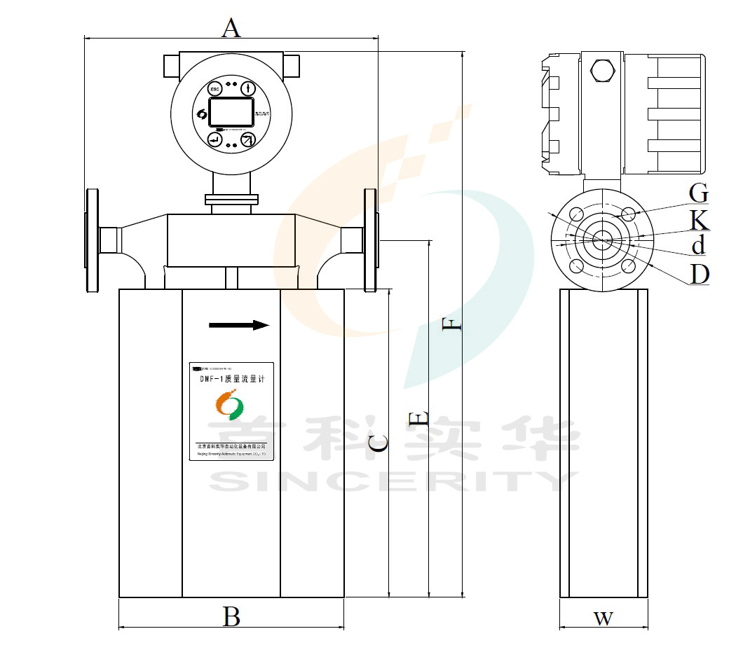

|  |  |  |  |  |  |  |  |  |  |  |  |  |
| --- | --- | --- | --- | --- | --- | --- | --- | --- | --- | --- | --- | --- |
| **Module** | **Welded Flange（GB/T9112-9124-2000）** | | **A** | **B** | **C** | **E** | **F** | **W** | **G** | **K** | **d** | **D** |
| **DN** | **MPa** |
| **DMF-1-U10** | **10** | **4.0** | **280** | **210** | **235** | **285** | **485** | **80** | **14** | **60** | **41** | **90** |
| **DMF-1-U15** | **15** | **4.0** | **280** | **210** | **275** | **325** | **525** | **80** | **14** | **65** | **46** | **95** |
| **DMF-1-U20** | **20** | **4.0** | **290** | **230** | **325** | **375** | **575** | **90** | **14** | **75** | **56** | **105** |
| **DMF-1-U40** | **40** | **4.0** | **520** | **360** | **480** | **585** | **790** | **130** | **18** | **110** | **84** | **150** |

**Unit: mm**

**Dimensions of Coriolis Mass Flow Meters**

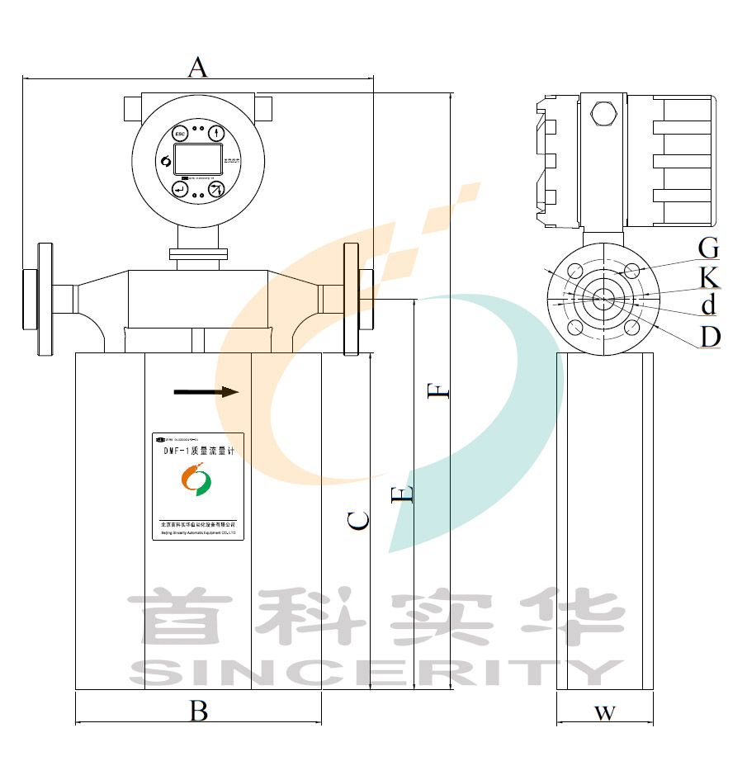**DMF-1-U25、DMF-1-U50**

|  |  |  |  |  |  |  |  |  |  |  |  |  |
| --- | --- | --- | --- | --- | --- | --- | --- | --- | --- | --- | --- | --- |
| **Module** | **Jap Joint Flange（GB/T9112-9124-2000）** | | **A** | **B** | **C** | **E** | **F** | **W** | **G** | **K** | **d** | **D** |
| **DN** | **MPa** |
| **DMF-1-U25** | **25** | **4.0** | **410** | **300** | **440** | **500** | **696** | **120** | **14** | **85** | **65** | **115** |
| **DMF-1-U50** | **50** | **4.0** | **550** | **370** | **548** | **670** | **875** | **153** | **18** | **125** | **99** | **165** |

**Unit: mm**

**Dimensions of Coriolis Mass Flow Meters**

**DMF-1-U80**

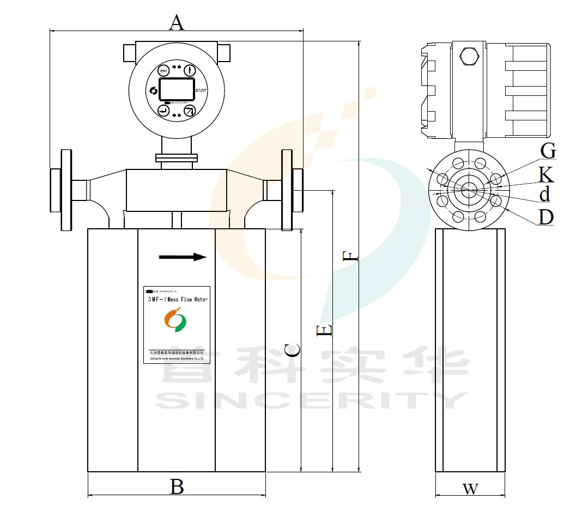

|  |  |  |  |  |  |  |  |  |  |  |  |  |
| --- | --- | --- | --- | --- | --- | --- | --- | --- | --- | --- | --- | --- |
| **Module** | **Jap Joint Flange （GB/T9112-9124-2000）** | | **A** | **B** | **C** | **E** | **F** | **W** | **G** | **K** | **d** | **D** |
| **DN** | **MPa** |
| **DMF-1-U80** | **80** | **2.5** | **660** | **470** | **650** | **767** | **988** | **220** | **18** | **160** | **132** | **200** |

**Unit: mm**

**Dimensions of Coriolis Mass Flow Meters**

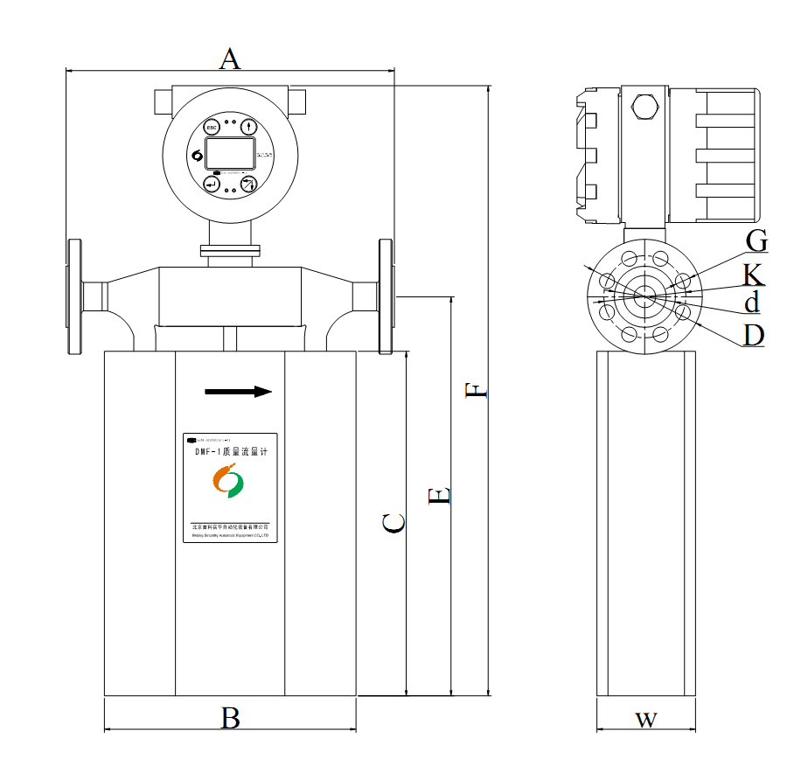**DMF-1-U65、DMF-1-U100、DMF-1-U125、DMF-1-U150**

|  |  |  |  |  |  |  |  |  |  |  |  |  |
| --- | --- | --- | --- | --- | --- | --- | --- | --- | --- | --- | --- | --- |
| **Module** | **Welded Flange** | | **A** | **B** | **C** | **E** | **F** | **W** | **G** | **K** | **d** | **D** |
| **DN** | **MPa** |
| **DMF-1-U65** | **65** | **4.0** | **560** | **440** | **600** | **715** | **836** | **200** | **18** | **145** | **118** | **185** |
| **DMF-1-U100** | **100** | **2.5** | **670** | **490** | **720** | **831** | **1052** | **220** | **22** | **190** | **156** | **235** |
| **DMF-1-U125** | **125** | **1.6** | **700** | **510** | **790** | **908** | **1142** | **260** | **18** | **210** | **184** | **250** |
| **DMF-1-U150** | **150** | **1.6** | **900** | **700** | **930** | **1110** | **1350** | **280** | **22** | **240** | **211** | **285** |

**Unit: mm**

**Dimensions of High Pressure Coriolis Mass Flow Meters**

**DMF-1-U10, DMF-1-U15, DMF-1-U20, DMF-1-U25**

**Attention: high pressure for DMF-1-U40, DMF-1-6 modules could be special ordered**

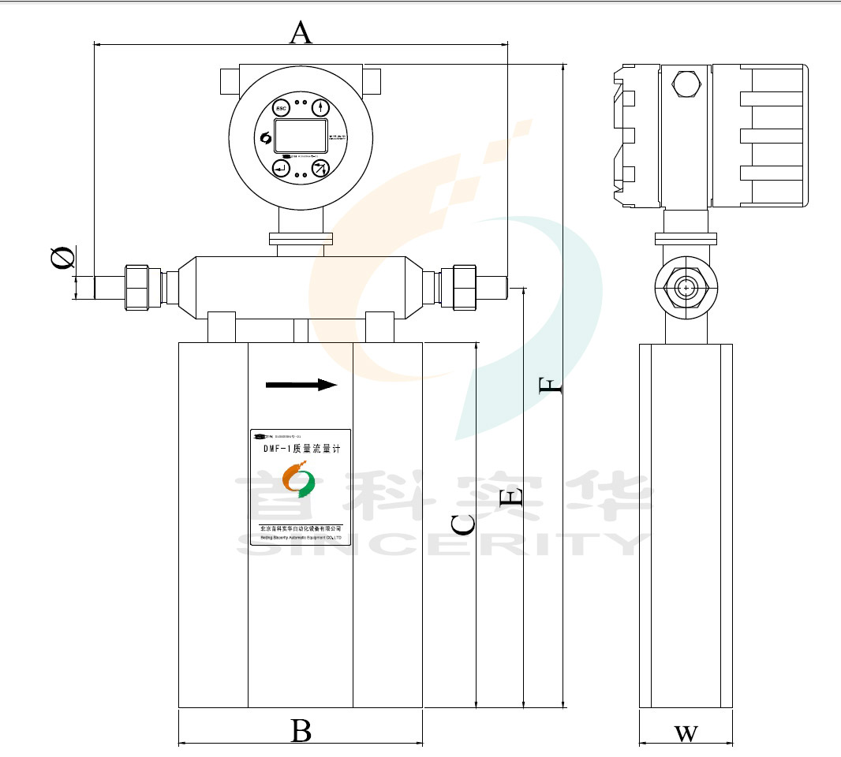

|  |  |  |  |  |  |  |  |  |  |
| --- | --- | --- | --- | --- | --- | --- | --- | --- | --- |
| **Module** | **Welded Flange** | | **A** | **B** | **C** | **E** | **F** | **W** | **Φ** |
| **DN** | **MPa** |
| **DMF-1-U10** | **10** | **25** | **346** | **210** | **235** | **282** | **482** | **80** | **20×4** |
| **DMF-1-U15** | **15** | **25** | **356** | **210** | **275** | **322** | **522** | **80** | **20×3** |
| **DMF-1-U20** | **20** | **25** | **376** | **230** | **325** | **372** | **572** | **90** | **20×2** |
| **DMF-1-U25** | **25** | **25** | **460** | **300** | **440** | **500** | **696** | **120** | **31×3** |

**Unit: mm**

**Tiny-Flow Coriolis Mass Flow Meters: DMF-1-1, DMF-1-2**

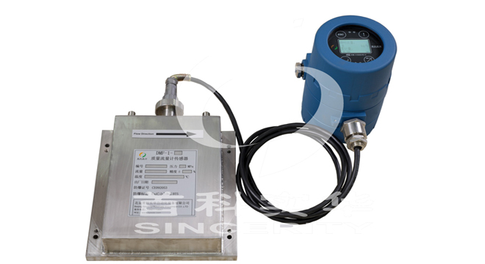

**Medium-Flow Coriolis Mass Flow Meters: DMF-1-3, DMF-1-4**

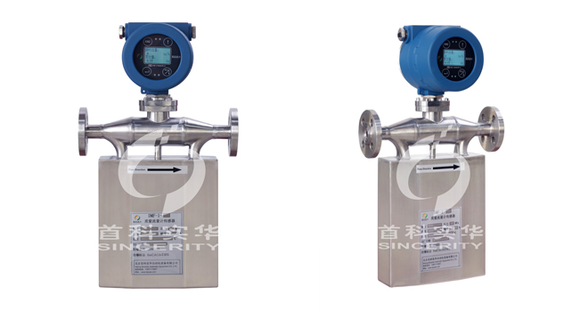

**Large-Flow Coriolis Mass Flow Meters: DMF-1-5, DMF-1-6**

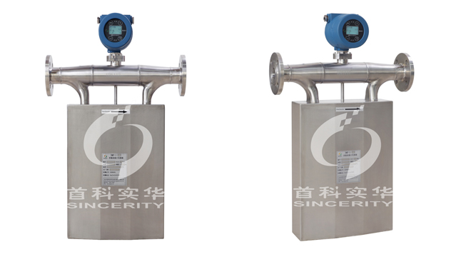

**High Pressure Coriolis Mass Flow Meters:**

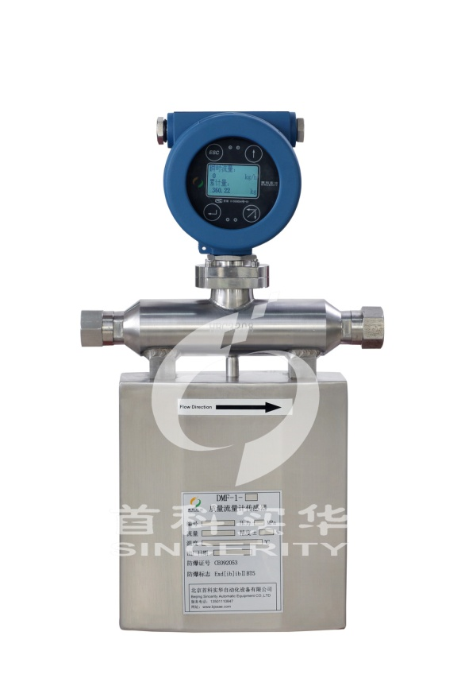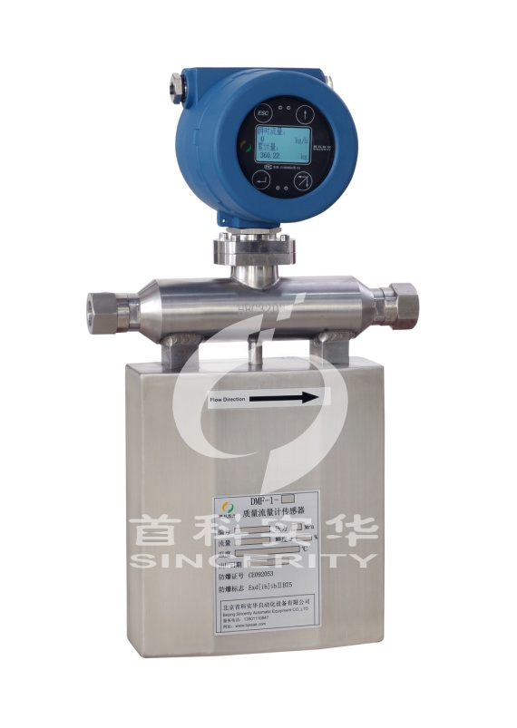

**Technical Indicators:**

Instantaneous Flow Accuracy: ±0.20% Flow Rate ±[(Zero Point Stability/ Flow Rate)* 100]% Flow Rate

Response Time: Factory set as 1 second. (could be adjusted by the users)

**Instantaneous Flow Rate Standard Precision Curve**



**Accuracy %**

**Flow Rate % Maximum**

Density Measurement Accuracy: ±0.002g/cm³ (Only applicable to liquid)

The origin coordinate starts with 0.5 as the graph shown below:

**Density Accuracy Curve:**

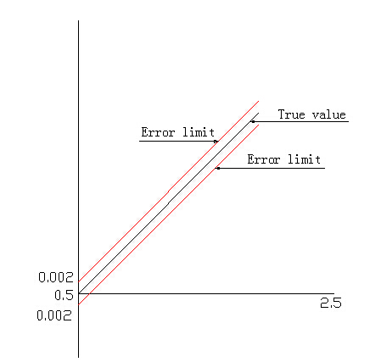

Density Measurement Range: 0.5- 2.5g/cm³

Temperature Measurement Accuracy: ±1℃

**Temperature Accuracy Curve:**

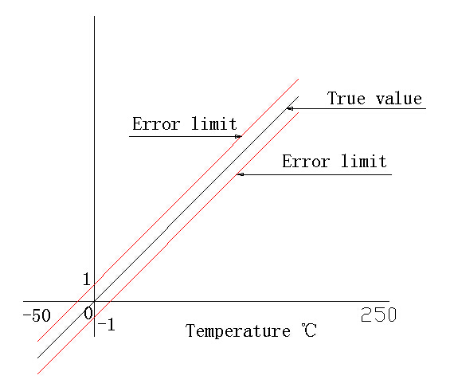

**Attention: Module Selection**

1. For the measurement of liquid, the most appropriate module should be selected based on the normal flow rate, maximum & minimum flow rate.
2. For the measurement of gas, the most appropriate module should be selected according to the velocity calculated based on normal flow rate, maximum & minimum flow rate, size of pipeline, pressure.
3. For the measurement of high viscosity liquid, or the double-phase liquid of liquid and solid, it is required
4. For the measurement of corrosive medium, would you please inform us the detailed name of the measured medium. And we will select the different materials of measuring pipeline (HC Hastelloy/ PTFE/ Titanium) based on the *Corrosion Prevention Manaul.*

We will select the most appropriate module based on the normal flow rate and the maximum flow rate provided. It is recommended that the normal flow rate would be above 1/3 of the designed flow rate range of different modules. And at the same time, it advised that the minimum flow rate of the users should be above 1/10 of the calibrated flow rate. Please contact us if there’s any special requirement. We could provide the customer-made modules based on the special technical requirements of the users. We will make sure the Coriolis Mass Flow Meters would meet all the requirements provided.

We will select the material of the sensor, pressure class and the temperature class based on the characteristics of the medium provided. And for sure, we will guarantee the anti-explosion proof will meet with the actual requirements of the users.

**Operation Conditions: Installation**

**Sensor Installation**

The proper installation is very important for the performance of the Coriolis Mass Flow Meters. The installation location should be chosen the place that easy for the maintenance. Would you please read the content of the chapter carefully before the installations

1. **Normal Installation**

It is recommended to release and empty he gas that possibly stored in the pipeline of the Coriolis Mass Flow Meters before installation.

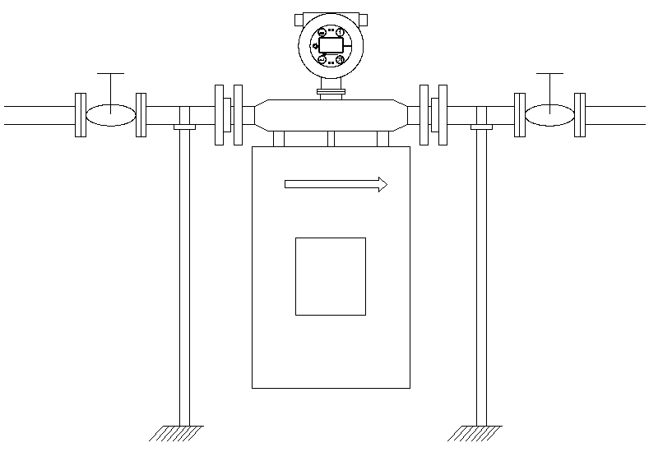

1. **Inverted Installation**

It is recommended to use the inverted installation for the measurement of Gas (e.g. steam). Because only in this way, the liquid that could possibly stored in the Coriolis Mass Flow Meters could be released and emptied.

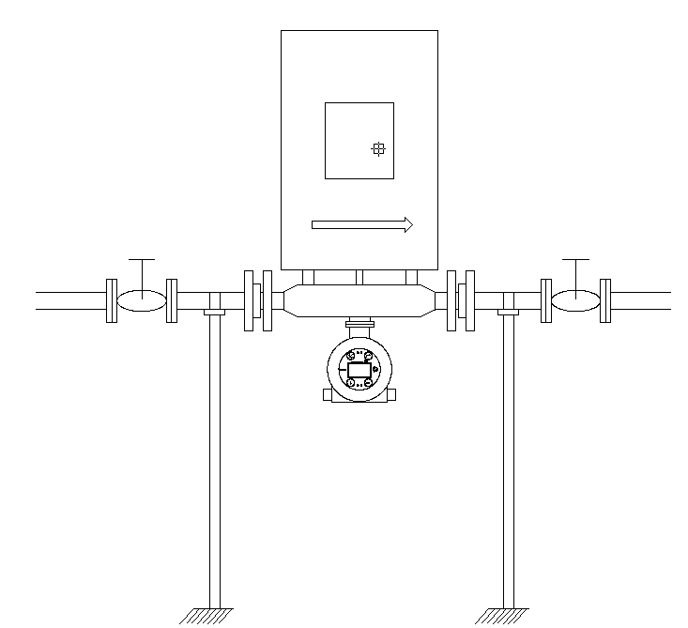

1. **Flag- Type Installation**

Flag- type installation is the installation way that the Coriolis Mass Flow Meter should be vertical to the horizontal line.

The measurement of suspension liquid, and the double-phase liquid of both liquid and solid is recommended to use the flag-type installation. E.g. For the liquid of easy solidification under the change of temperature, and for the liquid of high viscosity, it is required to empty the liquid left in the measuring pipeline after the measurement. The flag-type installation will not influence the measuring accuracy of the any types of liquid measured. But the direction of the measured flowing must be from bottom up.

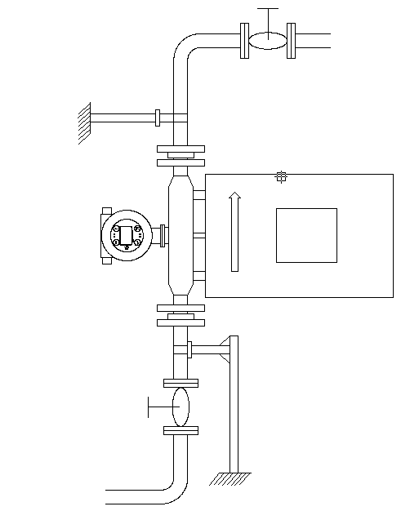

1. **Tiny Pipe-Size (DMF-1-S3~ DMF-1-S8) Installation**

The tiny- size Coriolis Mass Flow Meters’ flow range is very small, while the requirement about the accuracy is high. In this way, then the stable mounting plate and bracket are the must. The installation of mounting plate and Coriolis Mass Flow Meter must be completely flat without any space. If not, please use the level bolt to adjust the balance. The installation of the tiny- size Coriolis Mass Flow Meters is shown as below:

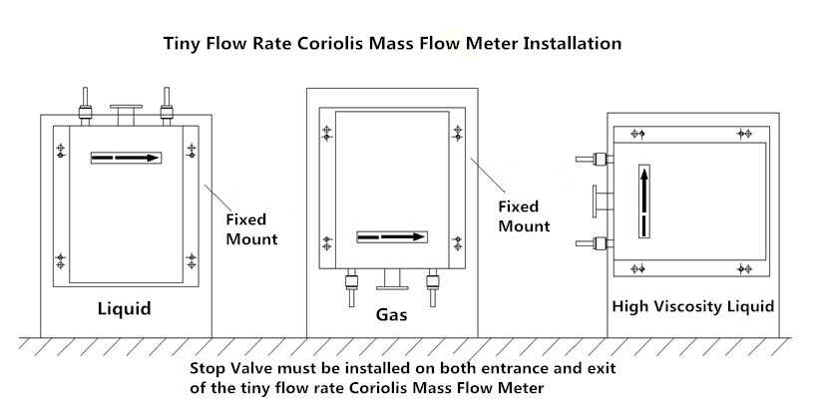

1. **Other Installation Requirements**
2. Coriolis Mass Flow Meters’ measuring principle is based on the controlled generation of vibration. So the installation location should be as far away from the vibration source as possible. And the stable support of the installation pipeline is required too. If the vibration source is inevitable, then it is recommended to use the hose connection. The connecting pipeline and the Coriolis Mass Flow Meter’s connection should be located in the same axis. And do not impose an additional force on mass flow meter. Unnecessary additional force will affect measuring accuracy.
3. If the installation of the throttle device is required, such as the flow control valve, then the installation must be installed at the export of the Coriolis Mass Flow Meter.
4. The cut-off valves should be installed at the entry and the export of the Coriolis Mass Flow Meters. And it is benefit for the first-time zero point calibration after the installation.
5. The Coriolis Mass Flow Meter should be as far away from the pump’s export as possible, especially the reciprocating pumps. The fluctuation of the flow measurement would be caused by getting too close to the pumps.
6. For the measurement of high temperature liquid, and the heat preservation is required, the insulation shell and the heating pipe must not directly contact with the sensor of the Coriolis Mass Flow Meters. Our company could provide the heat conduction specially designed for the Coriolis Mass Fow Meters Sensors. We could provide the steam heating, or the conduction oil heating.e could provide the steam heating, or the conduction oil heating. (Should be ordered in advance)
7. The measured liquid should be at a suitable flow state. If the flow state of the liquid is not suitable under the natural environment conditions, then the external improvement is required. It could be used to regulate the temperature of the fluid (heating/ cooling temperature), to make the current fluid to be at the right flow state.
8. Installation Direction: Please make sure that the direction of fluid flowing through the pipeline is the same direction with the arrow on the nameplate of Coriolis Mass Flow Meter.
9. The serial number of the sensor and the transmitter should be one-to-one correspondence. The change or replacement may cause the measurement error of the Coriolis Mass Flow Meters.

**Transmitter& Sensor Connection:**

The integration of the Coriolis Mass Flow Meter has been connected and installed before the delivery.

The separated transmitter and the sensor are connected by the special connection cables and connectors. If the separation installation of the transmitter and the sensor is required, please contact us in advance before placing the order. The maximum length should not exceed 300m.

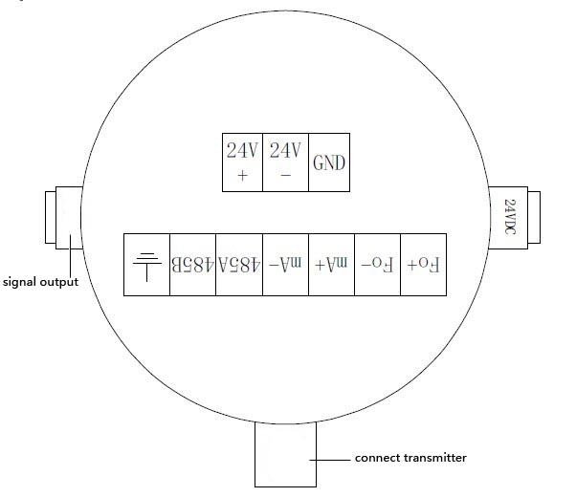

24V + \– 24VDC Power Supply (Current should not less than 500mA)

Fo + \– Frequency Output (instantaneous mass flow or volume flow)

mA + \– Current Output (instantaneous flow or density optional)

485A \485B RS-485 Communication (Baud Rate: “9600”, Address: “1”)

GND Signal Shielding



Instrument Shell

|  |
| --- |
| **Attention** |
| **The output frequency of the transmitter and the current output must not connect with any level of external power source.** |
| **Please refer to the anti-explosion part for the technical parameters about the dangerous occasions.** |

**Energizing & Inspection:**

1. **Please make sure that the wiring connection is correct before energizing the Coriolis Mass Flow Meters.**

The fault line protection is designed in the transmitters of the Coriolis Mass Flow Meters. But the wrong wiring connection may still cause the damage of the mass flow meters. So please make sure that the wiring connection is correct before energizing the Coriolis Mass Flow Meters.

1. **The screen will display “ Initializing, hold on…” after the energizing**

**Maintenance:**

**Common Trouble-Shooting:**

|  |  |  |
| --- | --- | --- |
| **Symptom** | **Failure Reason** | **Solution** |
| **No display** | Check whether is 24VDC power supply is normal | Make sure 24VDC is working normally |
| **Fluctuation of flow rate measured is large** | Whether there’s strong vibration of the line connected to the sensor | Adding support or switching to hose connection |
| **Could not enter the measuring interface after the boot** | Do not connect with the sensor | Check the cables, and make sure they are connected to the sensor properly |
| **Zero Point Drift is large** | The installation of the sensor has stress | The connecting line and the sensor interfaces should be at the same axis |

**Maintenance and Repair:**

The lifetime of the coriolis mass flow meters is related to the maintenance and repair. To extend the lifetime of the coriolis mass flow meters, please follow the steps listed as below:

1. Keep the mass flow meters clean, and try not to put in the dirty environment. And prevent from the explosion under the sunshine, and keep it away from water.
2. Carry and place the coriolis mass flow meters gently, and do not throw it.
3. Clean the measuring pipelines inside the mass flow meters regularly. For the medium with high viscosity, it is recommended to clean more often.
4. For the customers with high accuracy requirements, it is recommended to calibrate the mass flow meters regularly.

**Settings**

1. **Function Settings:**
2. **User’s menu password**

The user’s menu password is 20.

This password can be used for checking the records, modifying the settings, testing the output, and clearing the fault codes, etc.

1. **System Menu Password**

The system menu password is associated with the calibration parameters of the Coriolis Mass Flow Meters, and it is not recommended to modify. If it is required, please contact our company for the after-sales department. And please operate under the guidance of the relevant technical engineers. Thank you

1. **Unit Selection**

The range conversion is automatically processed under selecting different units.

**t/h kg/min L/min**

**kg/h g/min mL/min**

**g/h m3/h pounds/min**

1. **The selection of the decimal**

The display of 0- 3 decimal places is optical.

1. **Current Output Setting**

Flow/ Density (4-20)mA output

1. **Frequency/ Pulse Output Setting**

Frequency output or pulse output are optional.

Frequency output is corresponding to the instantaneous mass flow, or volumetric flow.

1. **Instrument Panel**

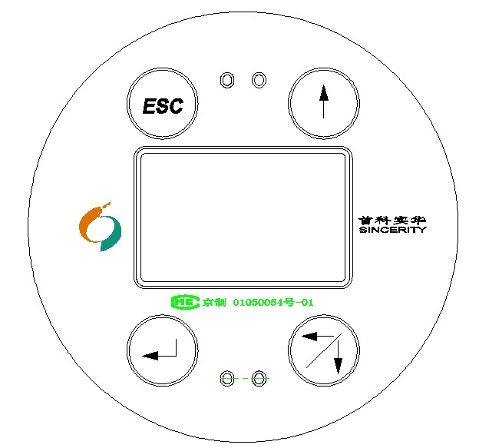

1. **Operating Interface:**

The touch button of the operating interface is light touch button. Please directly touch the button to operate.

**Boot Display:**

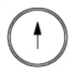

Touch or to switch between two interfaces:

Instant Flow

* 1. Kg/h

Total Flow

3256.562 kg

Density

1.000 g/cm3

Temp

25.3 ℃

**\*Customization Order: please contact us in advance if it is required**

Oil-Water Ratio

99.82 %

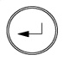**Touch ，and it will be displayed as below:**

Password

0

**Check the Record:**

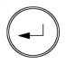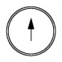

Touch ，and touch , input 20 (password). Then touch to enter.

**Enter the interface:**

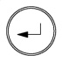

Touch to enter the next menu.

Records

Setting

Output Test

Clear Fault Code



Touch to scroll between several interfaces to check the information of the mass flow meters

Module

DMF-1-2

S/N

SN: 00-000

Flow Range

1000 kg/h

Version

Ver. 1.0

Fault Code

01

Touch “ESC” to enter the previous menu

**Setting**

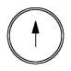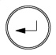

Touch , touch to enter 20, then touch to enter the next interface. And touch to enter the “Setting” interface.

Records

Setting

Output Test

Clear Fault Code

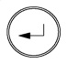

**Touch to enter**

For Example: 1) when the cursor is at “Clear”, touch to move to “Zero Point Calibrate”;

Clear

No

Zero Point Calibrate

No



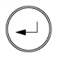2) Touch to enter, touch to choose yes, or no. Touch to enter. Or touch “ESC” to exit.

The mass flow meter will be restarted by touching this button.

Restart

No

Decimal

3

The decimal set for the mass flow meter is optical from 0-3

The unit set for the unit of the flow could be optical as below: t/h，kg/h，g/h，kg/min，g/min，m3/h，L/min，mL/min. If choosing the mass unit (volume), then the flow rate measured would be mass (volume).

Order

Instant Flow

Unit

Kg/h g/cm3

Tiny-Signal Terminate

1%

Response

0

（0~99）% Optical

（0~100）s Optical

Light

On

Current Output

Flow Rate

Choose the flow rate or density (4-20mA ) output

The density range is 0.5g/cm3~2.5g/cm3

**\*Customization Order: please contact us in advance if it is required.**

Please enter the density of these two medium: the density of medium 1, and medium 2.

Density 1：

1.000 g/cm3

Density 2：

0.800 g/cm3

The measuring interface would show the percentage of density 2.

*ATTENTION:*

1. *The density input for these two medium should not be equal.*
2. *The percentage is under the saturated processing. (0-100%)*

**Output Test**



Touch , touch to enter 20, then touch to enter the next interface. And touch to enter the “Setting” interface.

Records

Setting

Output Test

Clear Fault Code

This test will be used to test the (0-10)KHz pulse output signal, and (4-20)mA current output.



**Touch to enter the interface**



Output Test

0%

Touch to transfer the testing point

|  |  |  |  |  |  |
| --- | --- | --- | --- | --- | --- |
|  | **0%** | **25%** | **50%** | **75%** | **100%** |
| **(0—10)KHz** | 0KHz | 2.5KHz | 5KHz | 7.5KHz | 10KHz |
| **(4—20)mA** | 4mA | 8mA | 12mA | 16mA | 20mA |

*ATTENTION: The (0-10)KHz and (4-20)mA output signal are standard equipped with the power supply. It is forbidden to connect to the external power source. Otherwise it may cause damage of the Coriolis mass flow meters.*

**Clear Fault Code:**

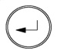

Touch , touch to enter 20, then touch to enter the next interface. And touch to enter the “Clear Fault Code” interface.

Records

Setting

Output Test

Clear Fault Code

It’s used to clear the history fault records.



**Touch to enter**



Clear Fault Code

No

Touch to choose “yes”, or “no”

Touch to enter. Or touch “ESC” to exit.

1. **Zero Point Calibrate**

Zero point calibration provides the datum point of the flow measurement. The zero point calibration must be conducted after the first time installation or re-installation.

The zero point calibration must be processed by cutting off the downstream shutoff valve firstly, and then cutting off the upstream shutoff valve. And make sure the sensor is fully filled with liquid during the process of zero point calibration.

**Explosive Prevention**

**Principles of Anti-Explosion Systems:**

DMF-Series Coriolis Mass Flow Meters are consist of the transmitter, sensor (It is equipped with the dedicated security gate). The DMF-Series Coriolis Mass Flow Meters are intrinsically safe explosion-proof products. Transmitters are associated apparatus especially for the sensors, and they adopt the flameproof shell. The explosion-proof is: EX d ib  II C T5 Gb

Dedicated Security Gate

[EXib]ⅡB

Associated Apparatus

Coriolis Mass Flow Meter Sensor

EX d ib  II C T5 Gb

Intrinsically Safe Anti-explosion

Coriolis Mass Flow Meter Transmitter

Safe Circuit

Special Cable

**Explosion-proof Performance**

Explosion-proof Performance meets with the terms of GB 3836.1-2010 and GB 3836.4-2010.

**Explosion-proof Performance Test**

Explosion-proof Performance inspection certification department conducts the test of the electrical products according to the terms of GB 3836.1-2010, GB 3836.2-2010 and GB3836.4-2010

**Documentation: RS 485 RTU Communication Protocol**

Address:

|  |  |  |  |
| --- | --- | --- | --- |
| **S/N.** | **Holding Register** | **Access Address (Hex/ Decimal)** | **Definition** |
| 1 | 41001 | 0x03E8 / 1000 | Mass Flow |
| 2 | 41003 | 0x03EA / 1002 | Volume Flow |
| 3 | 41005 | 0x03EC / 1004 | Total Mass |
| 4 | 41007 | 0x03EE / 1006 | Total Volume |
| 5 | 41009 | 0x03F0 / 1008 | Density |
| 6 | 41011 | 0x03F2 / 1010 | Temperature |
| 7 | 41013 | 0x03F4 / 1012 | Pipeline Vibration Frequency |
| 8 | 41015 | 0x03F6 / 1014 | Module |
| 9 | 41017 | 0x03F8 / 1016 | S/N |
| 10 | 41019 | 0x03FA / 1018 | Flow Unit |
| 11 | 41021 | 0x03FC / 1020 | Density Unit |
| 12 | 41023 | 0x03FE / 1022 | Range |
| 13 | 41025 | 0x0400 / 1024 | Decimal Places |
| 14 | 41027 | 0x0402 / 1026 | Tiny Signal Cut Ratio |
| 15 | 41029 | 0x0404 / 1028 | Display Refresh Time |
| 16 | 41031 | 0x0406 / 1030 | Internal Mass Flow Meter Parameters |
| 17 | 41033 | 0x0408 / 1032 | Internal Mass Flow Meter Parameters |
| 18 | 41035 | 0x040A / 1034 | Internal Mass Flow Meter Parameters |
| 19 | 41037 | 0x040C / 1036 | Measured Medium |
| 20 | 41039 | 0x040E / 1038 | Current Output Selection |
| 21 | 41041 | 0x0410 / 1040 | Input Password |
| 22 | 41043 | 0x0412 / 1042 | Internal Mass Flow Meter Parameters |
| 23 | 41045 | 0x0414 / 1044 | Internal Mass Flow Meter Parameters |
| 24 | 41047 | 0x0416 / 1046 | Internal Mass Flow Meter Parameters |
| 25 | 41049 | 0x0418 / 1048 | Total Data Clearance |
| 26 | 41051 | 0x041A / 1050 | Internal Mass Flow Meter Parameters |
| 27 | 41053 | 0x041C / 1052 | Internal Mass Flow Meter Parameters |
| 28 | 41055 | 0x041E / 1054 | Internal Mass Flow Meter Parameters |
| 29 | 41057 | 0x0420 / 1056 | Internal Mass Flow Meter Parameters |
| 30 | 41059 | 0x0422 / 1058 | Internal Mass Flow Meter Parameters |
| 31 | 41061 | 0x0424 / 1060 | Internal Mass Flow Meter Parameters |
| 32 | 41063 | 0x0426 / 1062 | Internal Mass Flow Meter Parameters |
| 33 | 41065 | 0x0428 / 1064 | Internal Mass Flow Meter Parameters |
| 34 | 41067 | 0x042A / 1066 | Internal Mass Flow Meter Parameters |
| 35 | 41069 | 0x042C / 1068 | Internal Mass Flow Meter Parameters |
| 36 | 41071 | 0x042E / 1070 | Internal Mass Flow Meter Parameters |

Attention:

Each holding register is 4 bytes (2 consecutive maintain registers), and it takes two addresses (low address). The register with a background in the tables is read-only register. The writing operation is invalid.

The address of 0x41049 is total-data clearance register. Write 0 in this address could process the clearance operation. Read the register and it will returns back to 1 (Floating point number).

The flow unit setting is 0-7 (The data will be transferred to 4-byte floating point number to transfer).

0🡺t/h；1🡺kg/h；2🡺g/h；3🡺kg/min ；4🡺g/min；5🡺m3/h；6🡺L/min；7🡺ml/min

The density unit setting is 0-2 (The data will be transferred to 4-byte floating point number to transfer). And it respectively stands for: g/cm3、g/L、t/m3

0🡺 g/cm3；1🡺g/L；2🡺t/m3

The current output selection is 0-1. And it respectively stands for flow and density. The data will be transferred to 4-byte floating point number to transfer.

The measured medium setting is 0-1. And it respectively stands for liquid and gas. The data will be transferred to 4-byte floating point number to transfer.

ModBus Communication (RTU Format)

Check Method: no check

Data Bits: 8

Stop Bits: 1

**ModBus Communication Protocol (RTU)**

1. Read N variables

The host requested information frame:

Mass Flow Meter Address+0x03+Register’s Starting Address（2bytes，High Byte is in the front）+ Number of Register’s Reading and Writing 2*N（2bytes，High Byte is in the front）+ CRC Check Code（2bytes，Low Byte is in the front）

Response Information from the machine frame:

Mass Flow Meter Address +0x03+Bytes of Data 4*N（1字节） + Register’s Data（4*N bytes，High Byte is in the front）+ CRC Check Code（2 bytes，Low Byte is in the front）

For Example:

1. Write N variables

The host requested information frame:

Mass Flow Meter Address +Function Code 0x10+ Register’s Starting Address（2 bytes，High Byte is in the front）+ Number of Register’s Reading and Writing 2*N（2bytes，High Byte is in the front） + Bytes of Data 4*N（1byte） +Data waiting to be written（4*N bytes，High Byte is in the front）+ CRC Check Code（2 bytes，Low Byte is in the front）

Response Information from the machine frame:

Mass Flow Meter Address + Function Code 0x10+ Register’s Starting Address（2 bytes，High Byte is in the front）Number of Register’s Reading and Writing 2*N（2bytes，High Byte is in the front）+

（2 bytes，Low Byte is in the front）



**Beijing Sincerity Automatic Equipment CO.，LTD**

**Company address：No. 8 building, 3rd. district,I-Town, Gaoli Zhang road，Haidian District,Beijing, China**

**Zip Code：100095**

**Fax：+86-010-62469399**

**Tel：+86-010-62469399/62468399**

**Contact: Ms. Zoe Pan**

**Phone: +86-18600270515**

**Web：www.bjssae.com**